The Historical Society of Riverton

*Presents*

Burlington County : Rooted in Agriculture

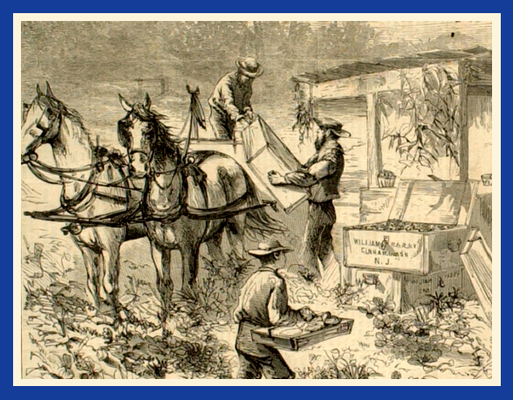

**Strawberry harvest at William Parry’s Farm, Cinnaminson, N.J. 1869**

**March 26, 2025**

**Riverton Library, 7:00**

**Speaker: Marisa Bozarth, Museum Curator, History at Burlington County Division of Parks**

**Free, open to Community**

**An exhibit of Dreer Nursery artifacts will be on display**