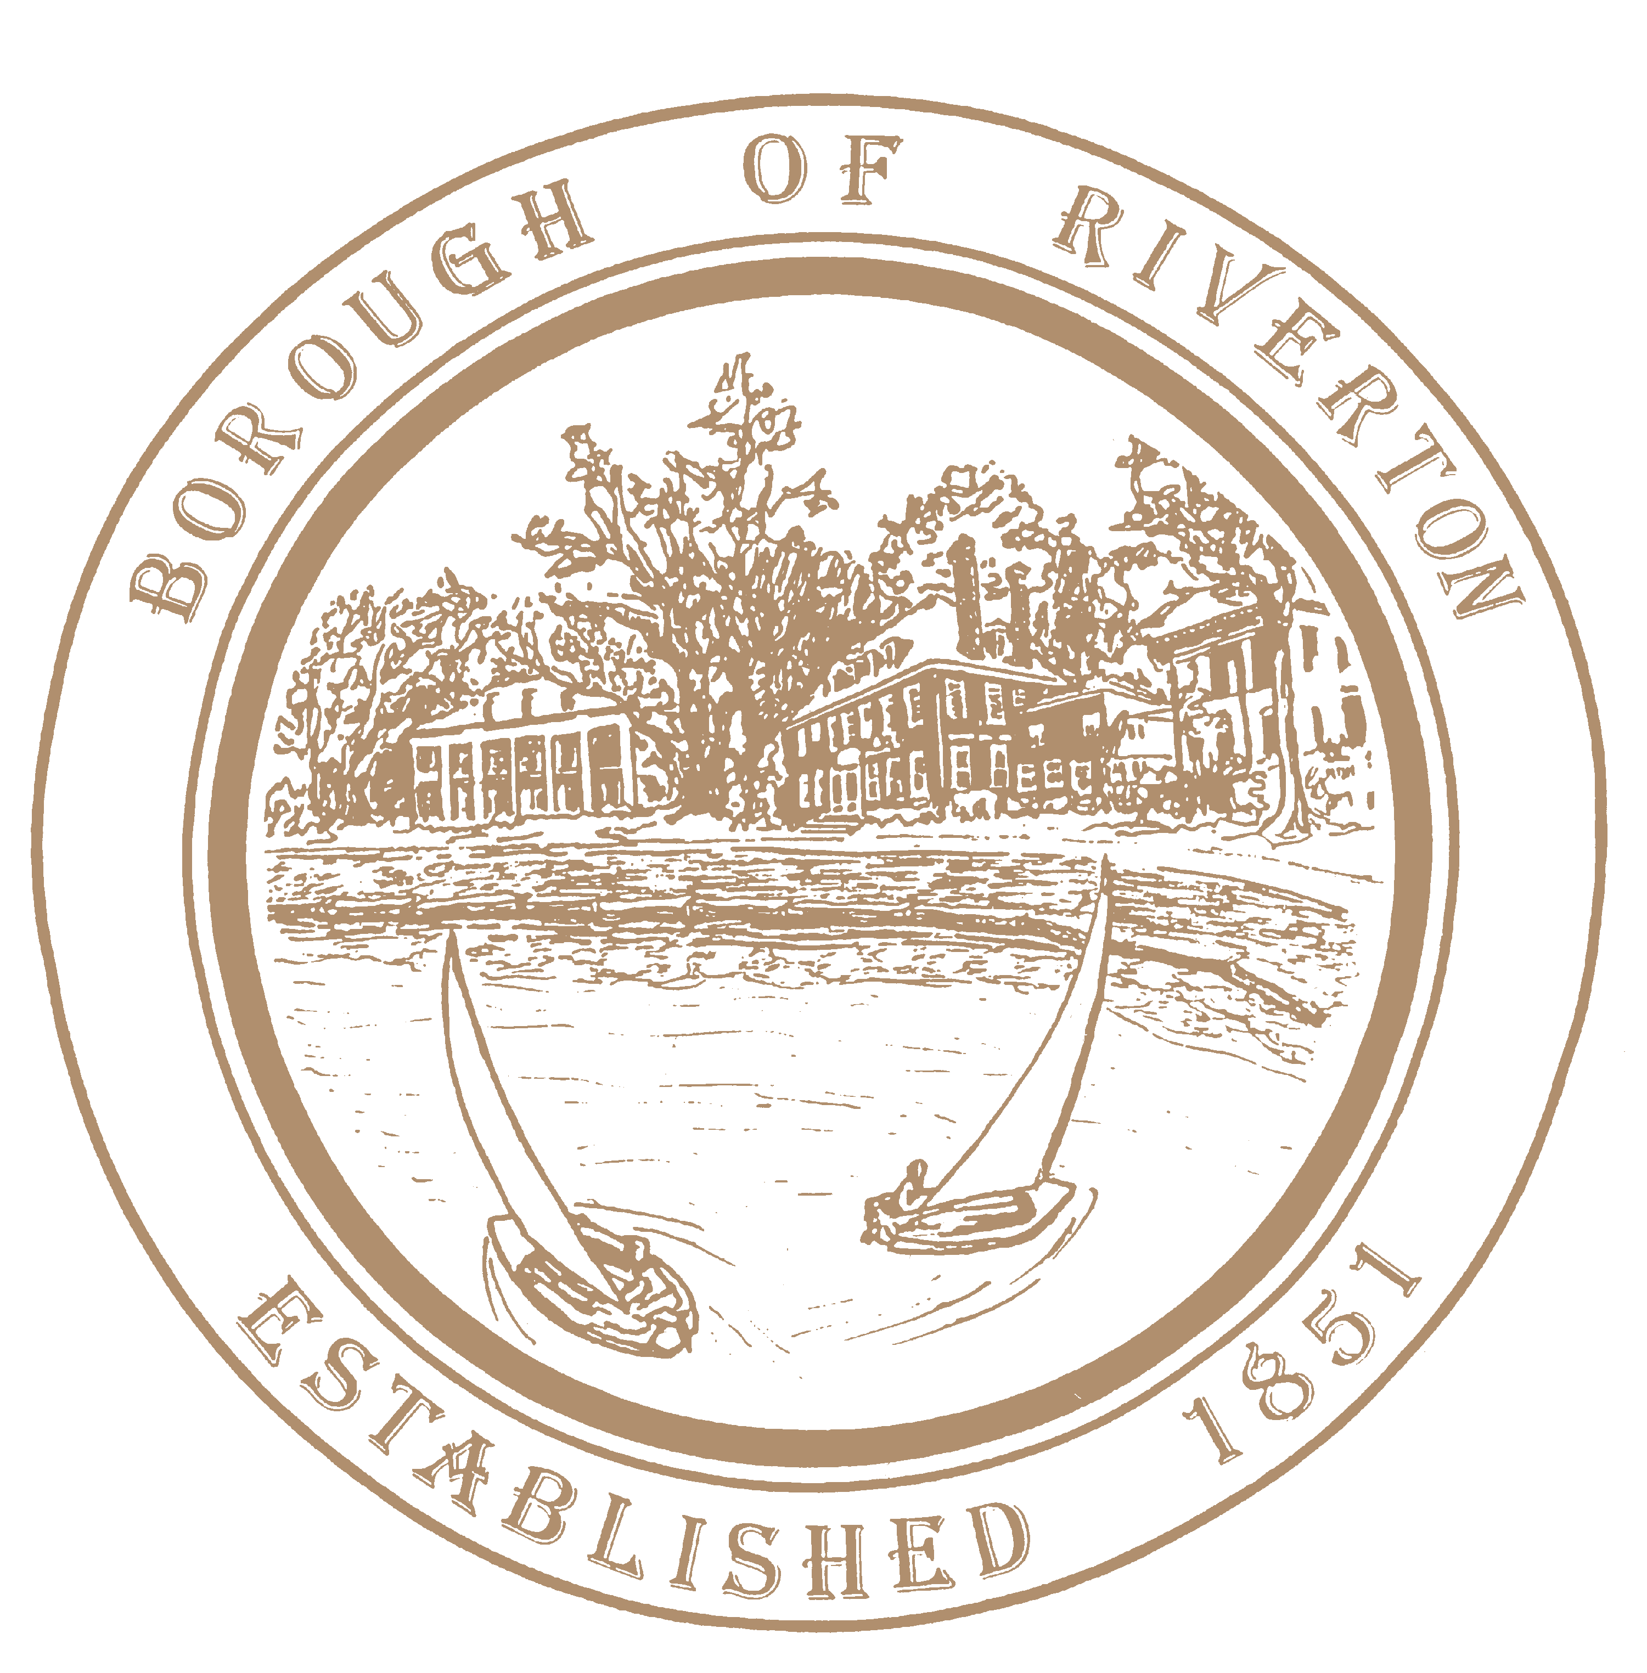

The Borough of Riverton has an immediate opening for a part-time Planning Board secretary. Responsibilities include but are NOT limited to:
- Scheduling and attending Planning Board meetings, hearings and deadlines;
- Preparation and distribution of agendas and minutes;
- Collection of all development applications submitted with correct application fees and escrow as required by local ordinance;
- Communicate with Board professionals to determine application completeness upon submission and communicate findings to applicants;
- Ensure completed applications and professional reports are submitted and disseminated with application to Board members and to Borough webmaster;
- Handling all of the Board’s correspondence;
- Establishing and maintaining all board records and files, including development applications, minutes, correspondences, memos, reports, and plans;
- Arranging and preparing for the publication of various public notices;
- Must attend all Planning Board meetings and hearings (currently the 4th Tuesday of the month), take minutes, handle the paperwork, and record during meetings;
- Annually prepare for Re-organization, including resolutions, end of year report for Board approval, schedule and deadlines for the year, and ensure annual professional contracts are secured.
This position averages 12-15 hours per month. Must have a high school diploma or equivalent and 2 years of clerical experience. Candidate must be a self-starter and able to work with very little supervision. Planning/Zoning Board knowledge a plus. Please send resumes to kandrews@riverton-nj.com. No phone calls will be accepted.

