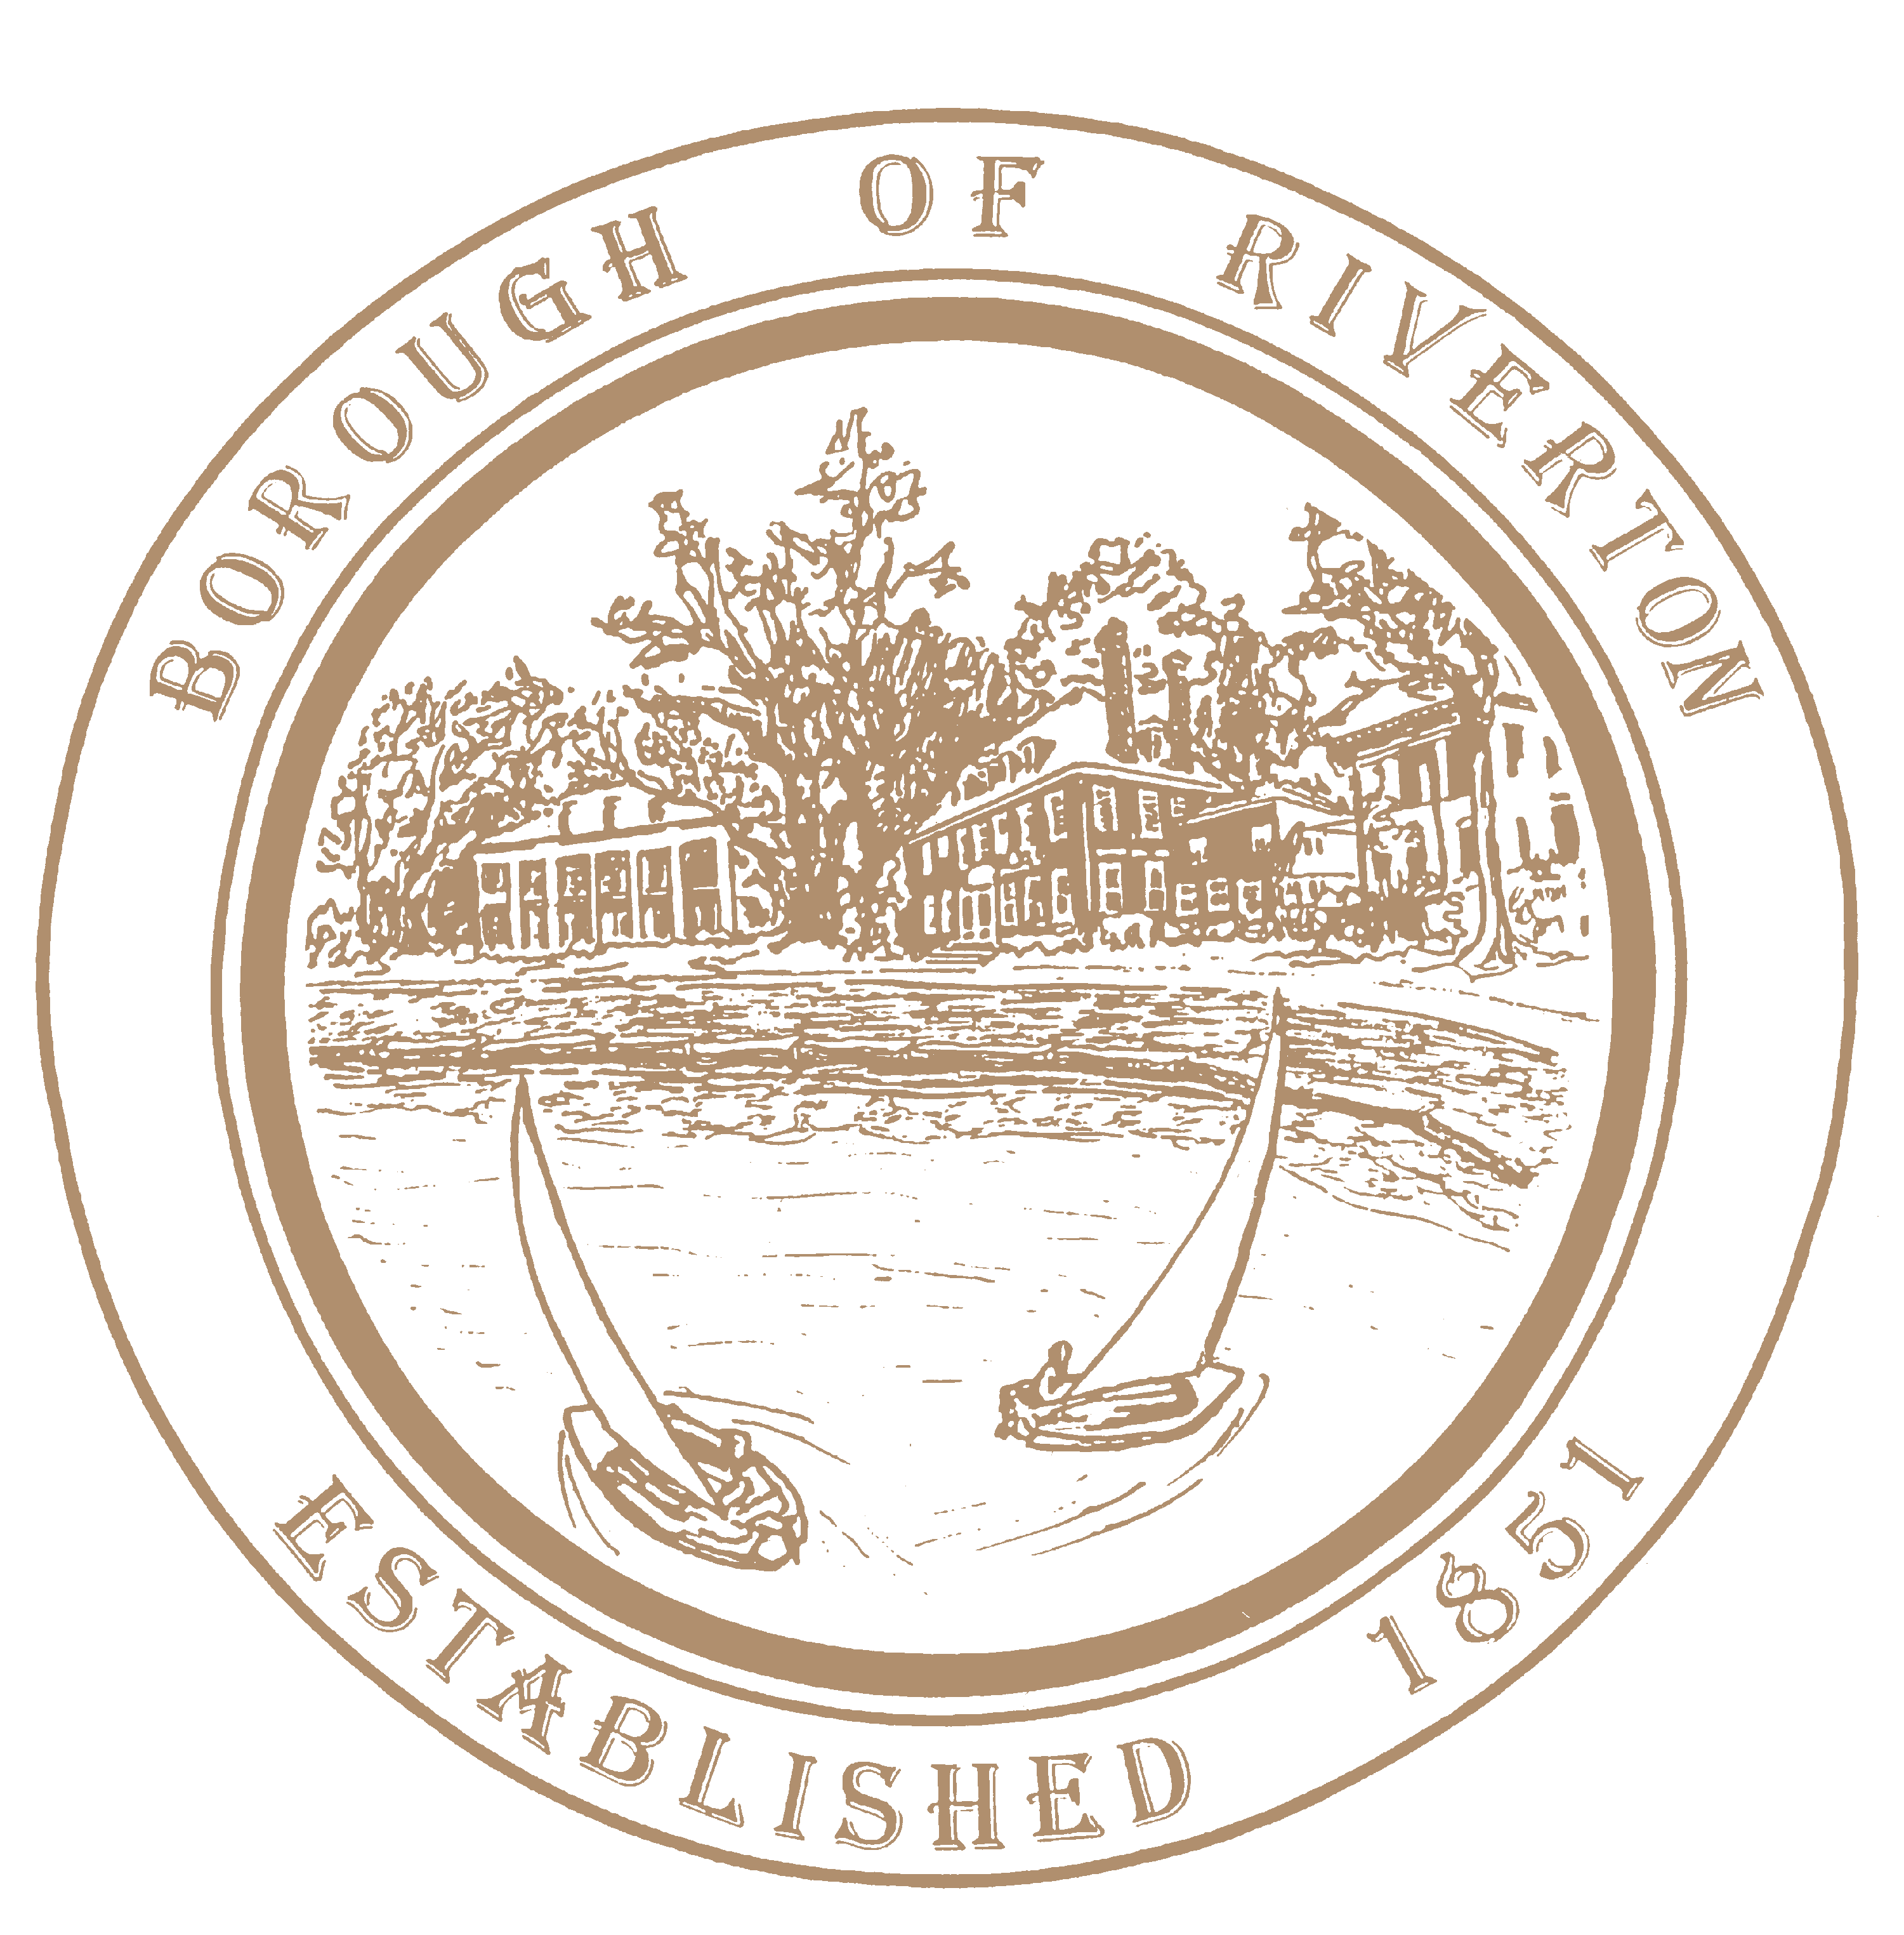

# Mayor

**James Quinn**

**Borough Council**

Kirk Fullerton, Council President

William Corbi, Councilman

Nicole Rafter, Councilwoman

Julie Scott, Councilwoman

Scott Reed, Councilman Edgar Wilburn, Councilman

**Kelly Andrews, RMC, CMR** Municipal Clerk [kandrews@riverton-nj.com](mailto:kandrews@riverton-nj.com)

505A Howard Street

Riverton, NJ 08077

TELEPHONE: (856) 829-0120

Fax: (856) 829-1413

[www.riverton-nj.com](http://www.riverton-nj.com/)

October 30th, 2024

**PUBLIC NOTICE:**

**ADVISORY: STAGE 3 FIRE RESTRICTIONS IN EFFECT**

in response to prolonged dry conditions and increased wildfire activity until further notice all fires will be prohibited unless contained in an elevated stove using only propane, natural gas, gas, or electricity. No charcoal fires are allowed.

For further information, please visit [NJDEP | New Jersey Forest Fire Service](https://www.nj.gov/dep/parksandforests/fire/)