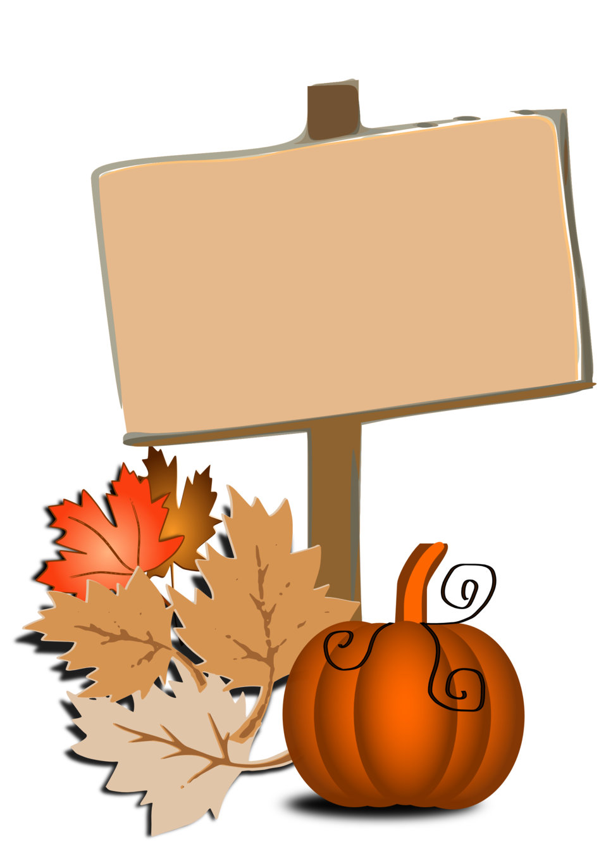

*FALL REMINDERS*

FROM THE OFFICES OF

PUBLIC WORKS AND

CODE DEPT.

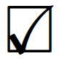

**Bulk Trash:** First Friday of each month: November 3rd and December 1st. Please note: ALL Mattresses Must be bagged!

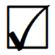

**NO MORE BRUSH:** after **Monday** **October 23 at 7 a.m.** which is the date for the final brush clearing of the Borough. After that date, residents may dispose of their brush at the Public Works yard during working hours.

**LEAVES:** must be to the curb by **Monday** **7 a.m.** the WEEK OF PICKUP!

River side of Borough Pick up weeks: October 30, November 13, November 27, 2023

Park side of Borough Pick up weeks: November 6, November 20, December 4, 2023

**ALL SIGNS:** Election, Contractor, Schools, Awareness, and any other yard signs **MAY NOT** be placed on Borough property or easements which is the strip of lawn between the sidewalk and the street.

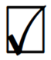

**TRASH**: must be at the curb **NO LATER than 6 a.m.** on the day of pick up to ensure pick up as 6 a.m. is the designated time the drivers start, and the route is at their discretion.