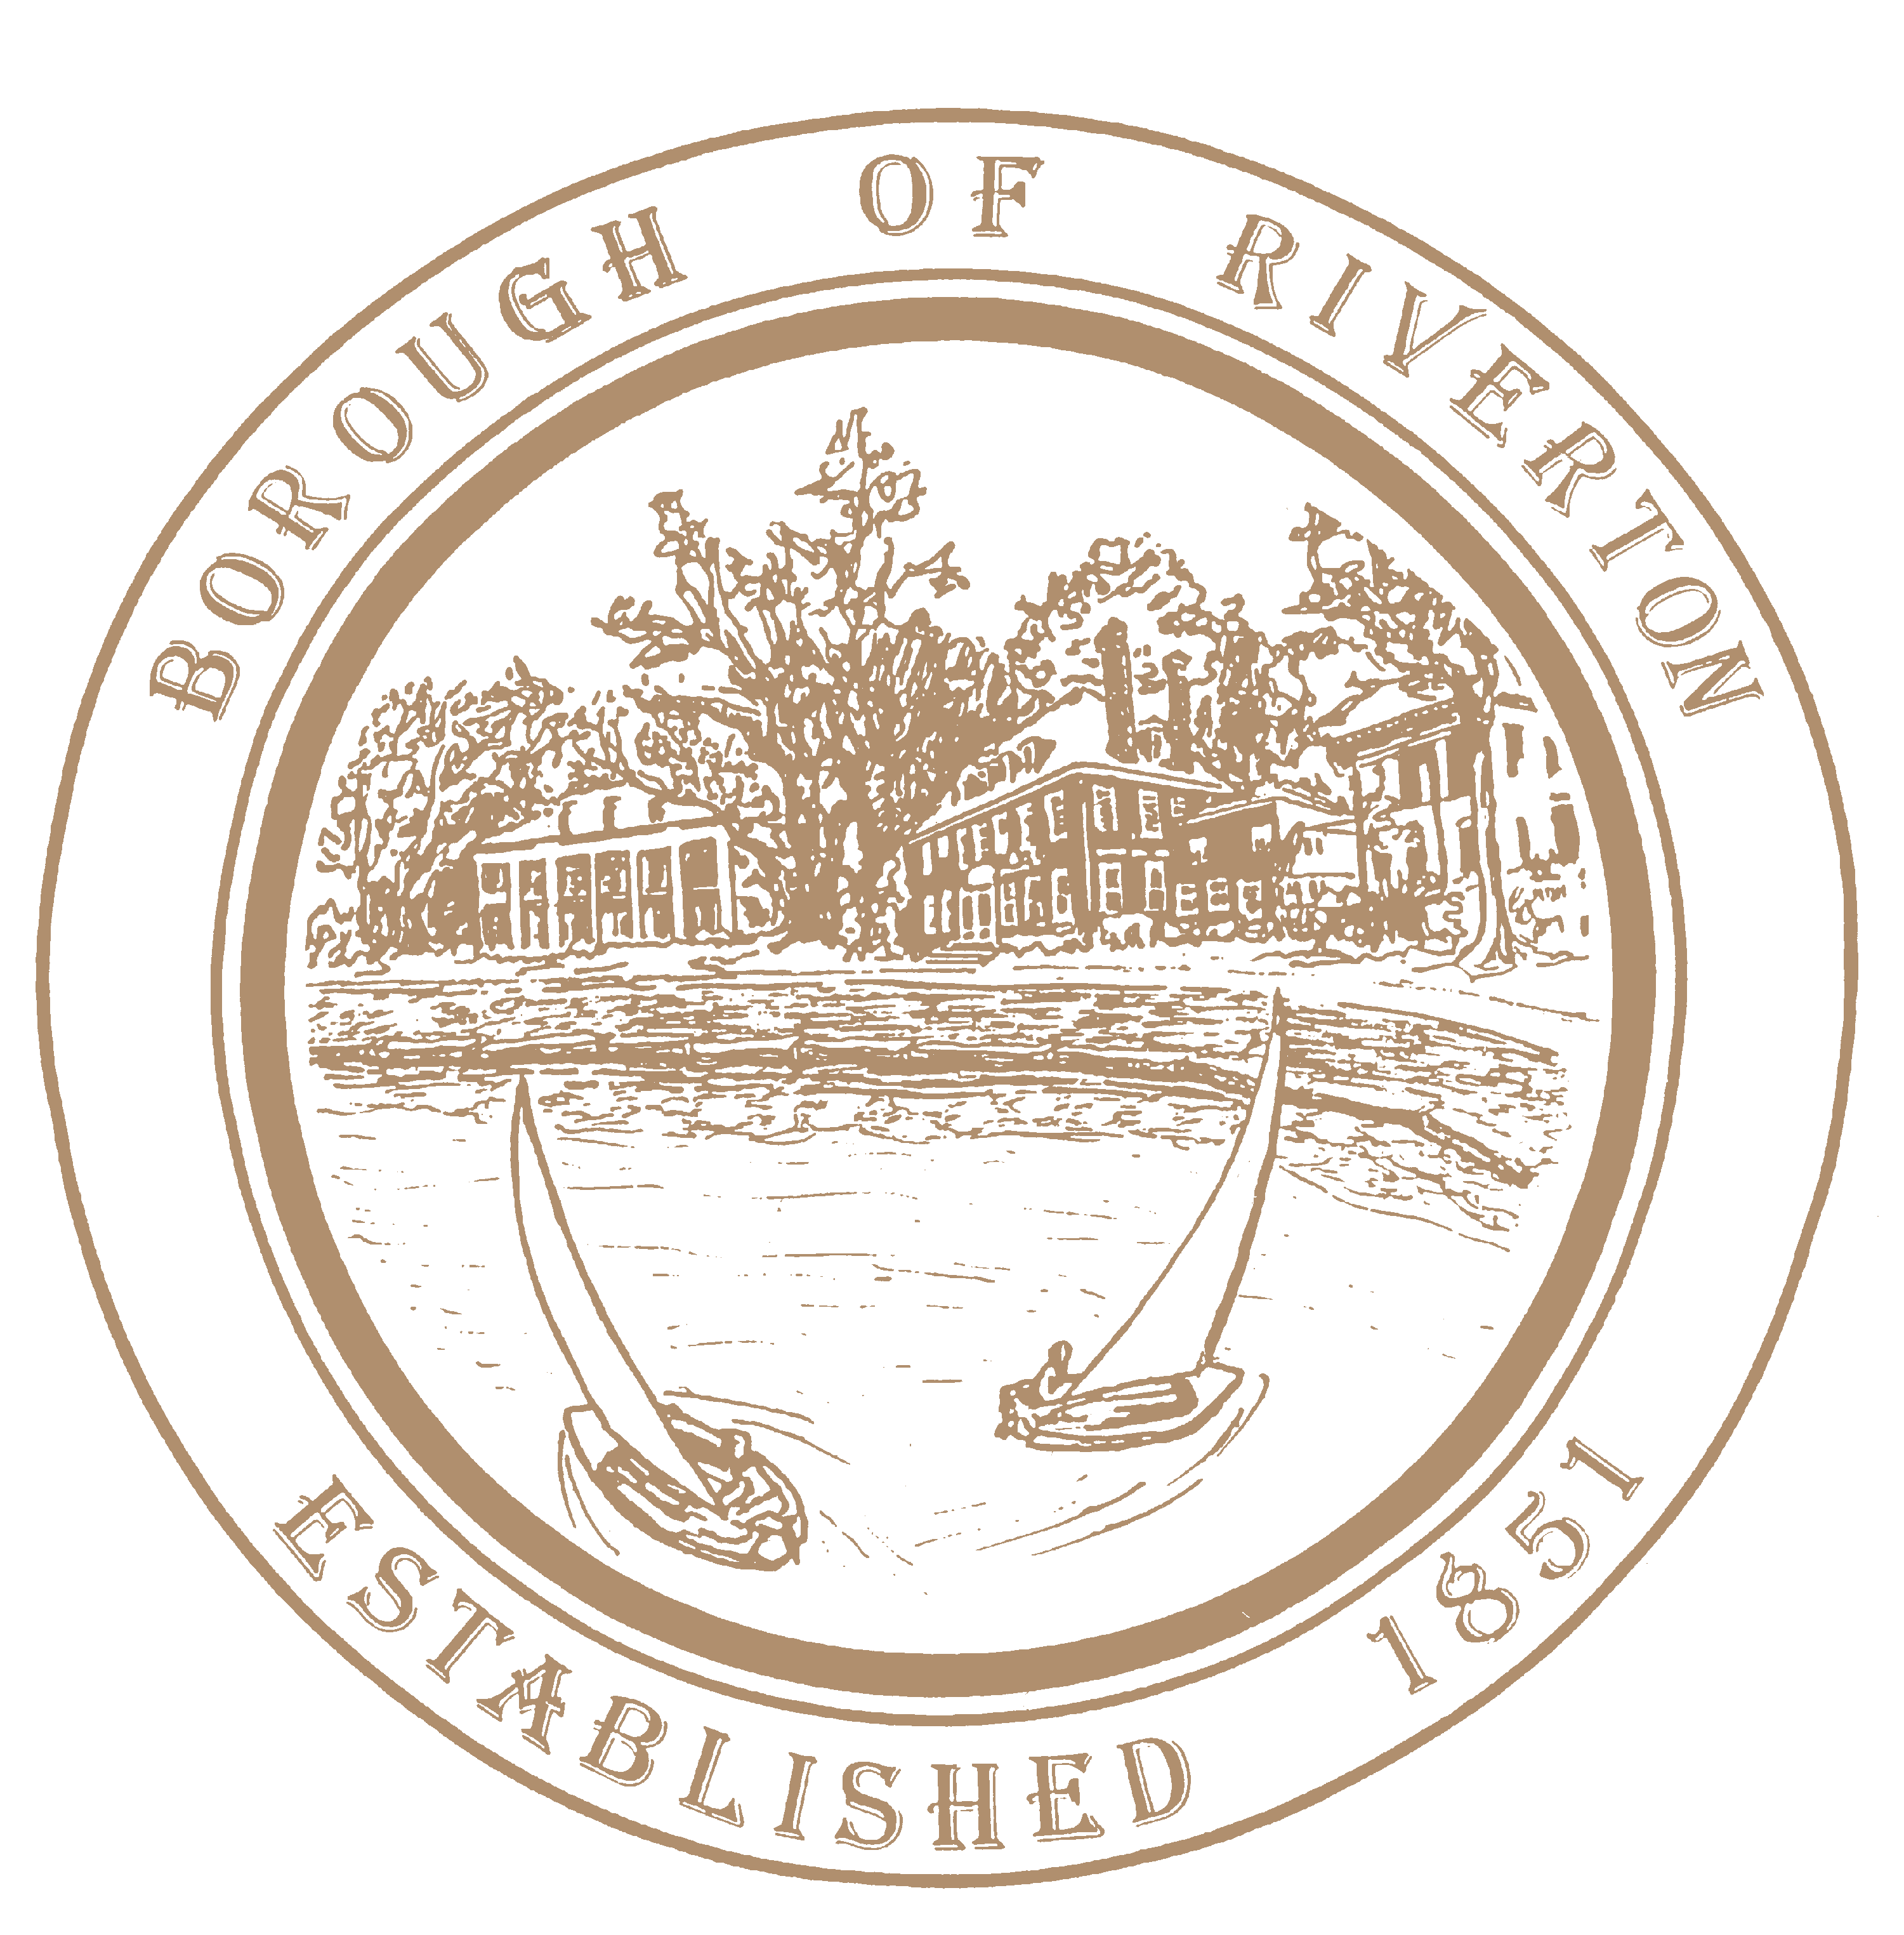

Mayor
Suzanne Cairns Wells

Borough Council
William Corbi, Council President Kirk Fullerton, Councilman
James Quinn, Councilman
Nicole Rafter, Councilwoman
Julie Scott, Councilwoman
Edgar Wilburn, Councilman
Michelle Hack, RMC, CMR Municipal Clerk mhack@riverton-nj.com

505A Howard Street
Riverton, NJ 08077
TELEPHONE: (856) 829-0120
Fax: (856) 829-1413
www.riverton-nj.com

PUBLIC NOTICE
REQUEST FOR PROPOSALS AND REQUEST FOR QUALIFICATIONS
FOR PROFESSIONAL SERVICES FOR THE YEAR 2024
FOR THE POSITION OF Human Resources Consultant
______________________________________________________________________________

PUBLIC NOTICE IS HEREBY given that on October 17, 2023 the Governing Body of the Borough of Riverton, in the County of Burlington has hereby authorized the Borough Clerk to advertise for Request for Proposals and Qualifications (RFP/RFQ) pursuant to a fair and open process in accordance with N.J.S.A. 19:44A-20.5 and N.J.A.C. 17:27-1.1 et seq. for the position of Human Resources Consultant.

All sealed proposals are to be returned to the Borough Clerk’s office on or before Thursday, December 7, 2023 at 4:00 P.M.; and shall be opened on Monday December 11, 2023 at 1:00 P.M. at the Borough Hall. The Borough assumes no responsibility for delivery methods.

Respondents for the he RFP for Human Resources Consultant shall provide compliance training and mechanisms for a municipal government agency consisting of 11 Full Time employees, 6-15 Part Time employees, 7 members of the Governing Body. Also sought in the RFP should be costs and timelines for the following, but not limited to, employee handbook analysis with revisions, in-person training with handouts/takeaway materials, workplace assessment, goal and need establishment, and legal counsel fees.

Submission Instructions:
1. Respondents are required to comply with the requirements of NJSA 10:5-31 et seq. and NJAC 17:27-1 et seq.
2. Sealed bid packages shall include 1 printed copy of the proposal and 1 electronic file in the form of a USB of the respective proposal(s) should be submitted.
3. The package should include detailed qualifications and fee schedules, insurance riders, New Jersey Business registration, W-9 and Iran Russia Belarus Disclosure Form and New Jersey Public Works registration (if required).

4. Mail to the Borough Hall at the address given below and noted below:
Office of the Municipal Clerk
Borough of Riverton
505A Howard Street
Riverton, NJ 08077
“Proposal for 2024 Human Resources Consultant for the Borough of Riverton”.

The Borough of Riverton reserves the right to choose one or more professionals, or to choose not to make a selection based on the notice, or to post subsequent notices for the same, similar, or different services.

All selections will be based on the review of the documents and information submitted, as well as independent research performed by the Borough, such as a review of references, an evaluation of performance with other governmental and non-governmental entities and/or all other available information.

Attest:

Michelle Hack, RMC
Municipal Clerk

