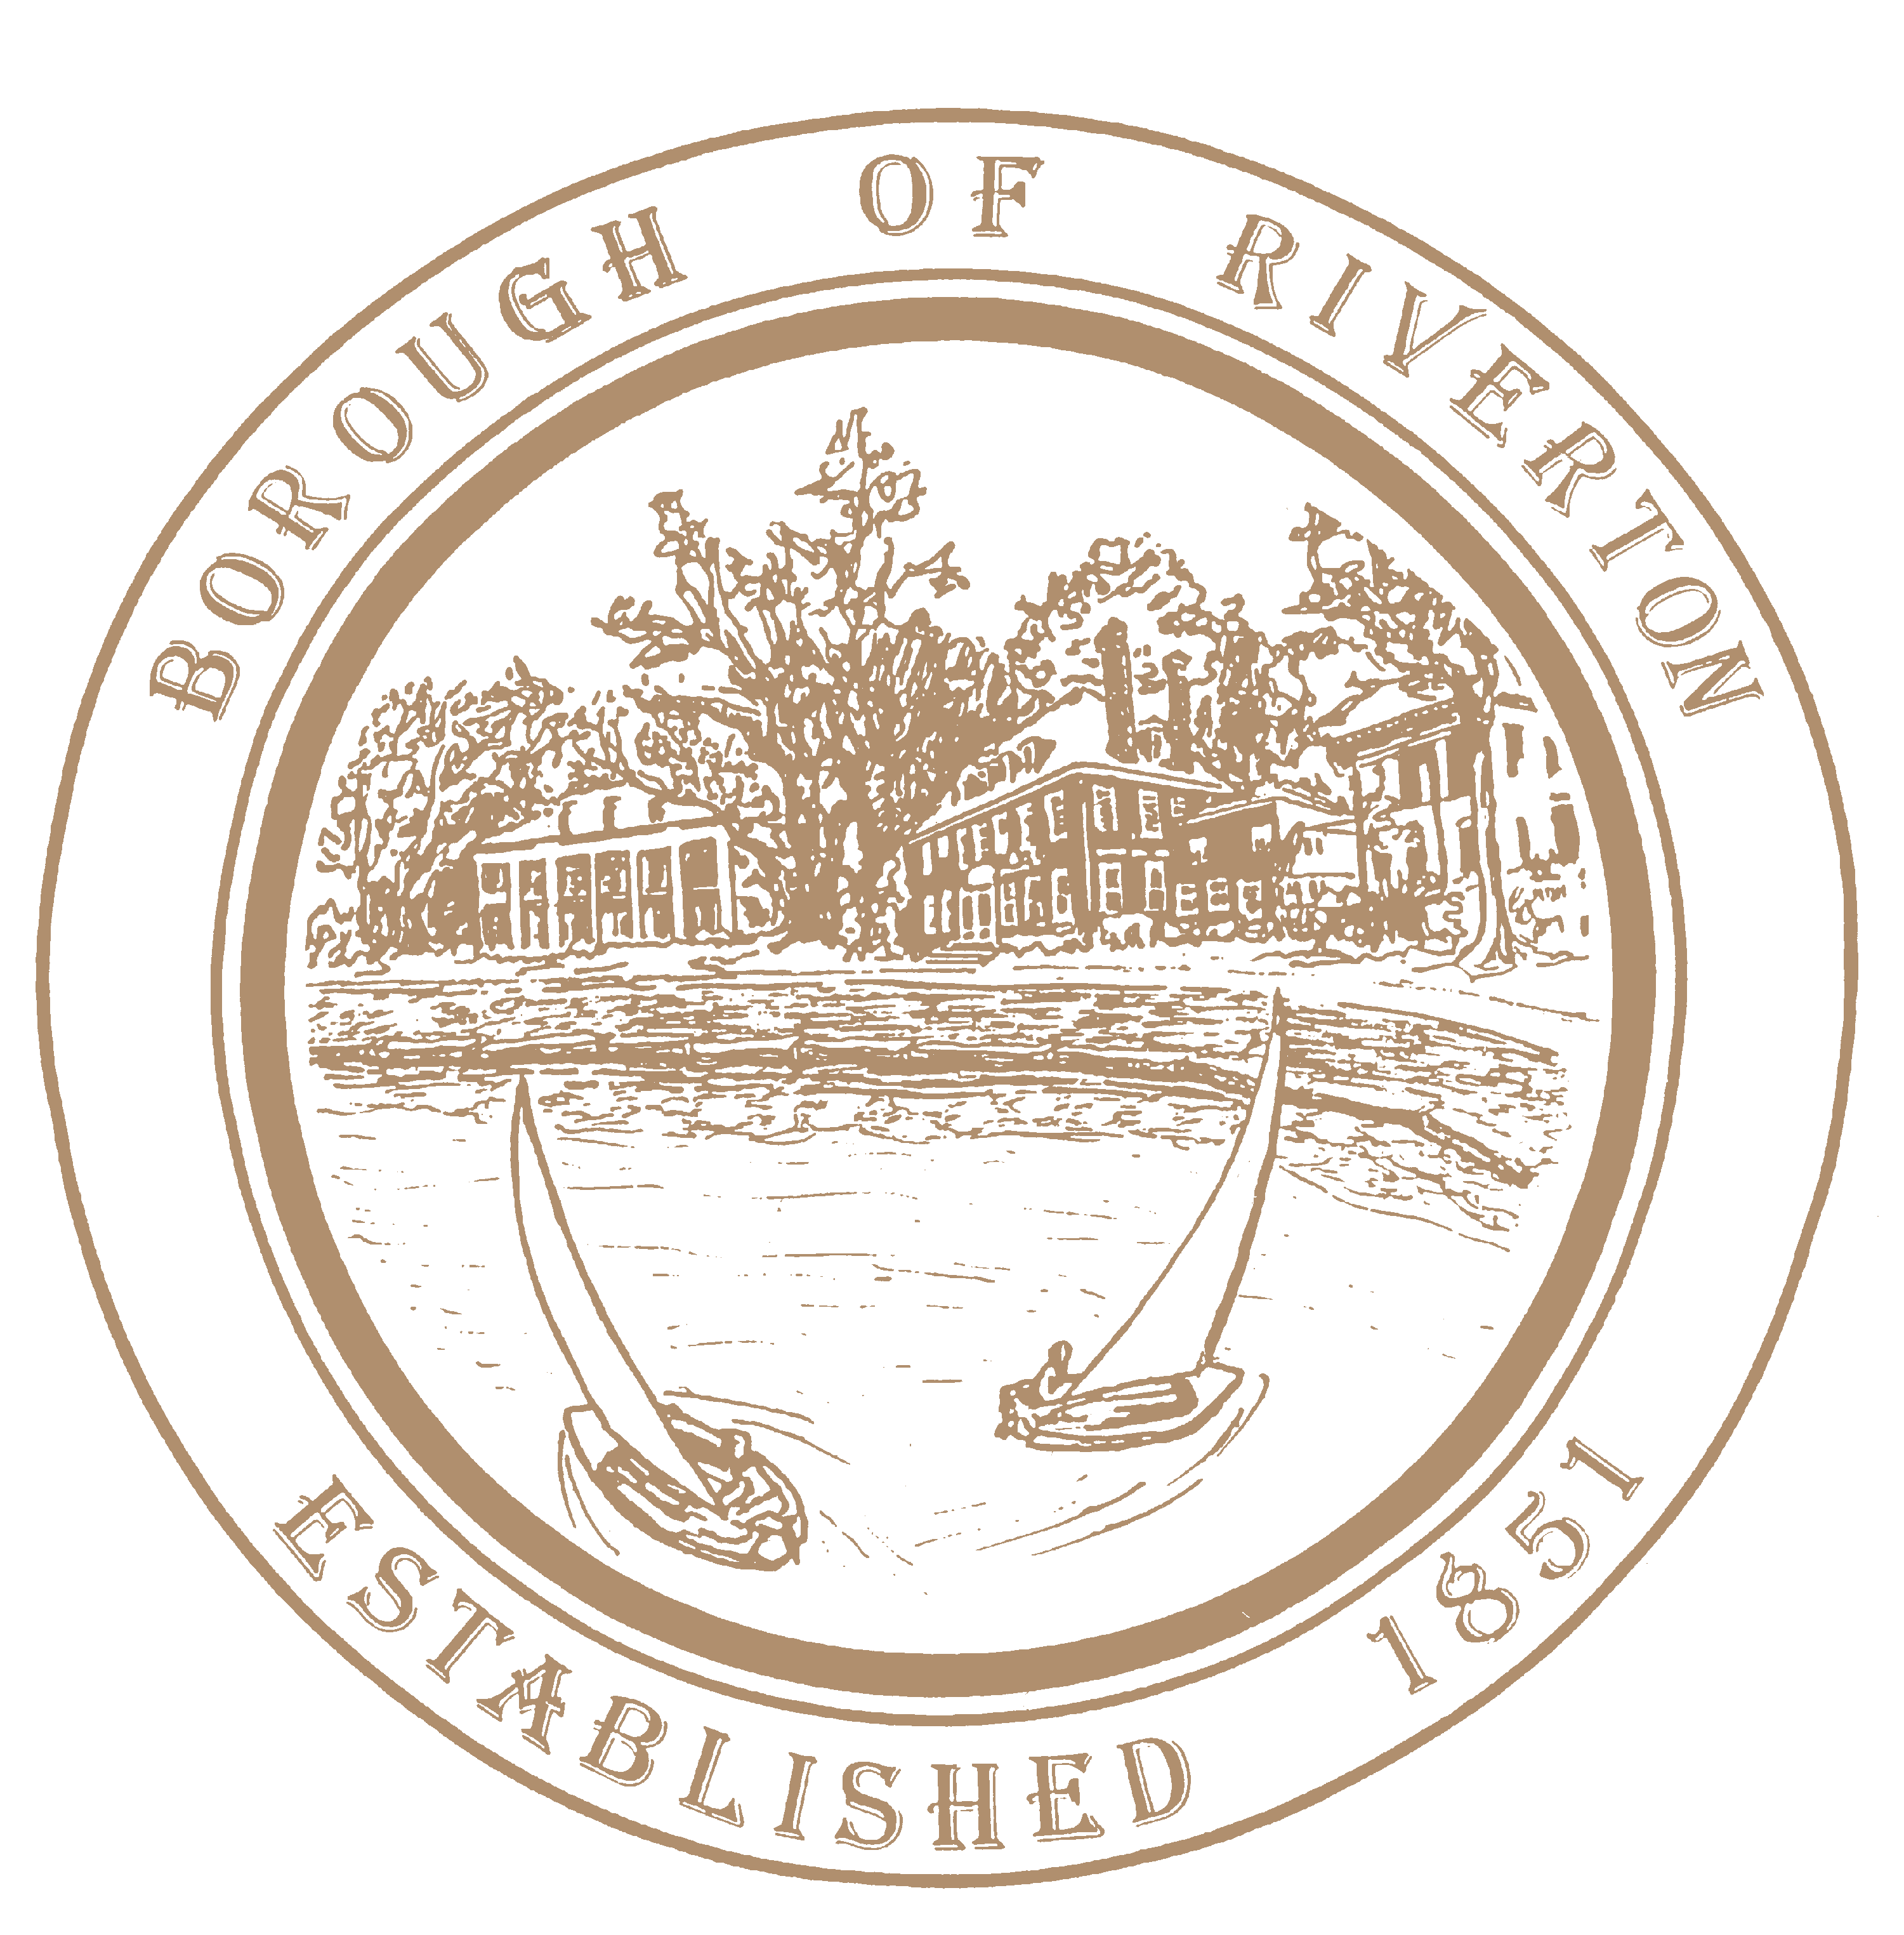

Mayor
Suzanne Cairns Wells

Borough Council
William Corbi, Council President Kirk Fullerton, Councilman
James Quinn, Councilman
Nicole Rafter, Councilwoman
Julie Scott, Councilwoman
Edgar Wilburn, Councilman
Michelle Hack, RMC, CMR Municipal Clerk mhack@riverton-nj.com

505A Howard Street
Riverton, NJ 08077
TELEPHONE: (856) 829-0120
Fax: (856) 829-1413
www.riverton-nj.com

Sunshine Notice
Special Meeting of the Governing Body of the Riverton Borough
_____________________________________________________________________________

PLEASE TAKE NOTICE, there will be a special meeting held at Riverton School to hear public comments on the adoption of the Historic Preservation Commission ordinance which will govern demolitions on October 11, 2023, at the Riverton School Gymnasium 600 Fifth Street at 6PM.

PLEASE TAKE FURTHER NOTICE that formal shall be taken and no other business will be addressed.

Attest:

Michelle Hack, RMC
Municipal Clerk
Attest:

Michelle Hack, RMC
Municipal Clerk

