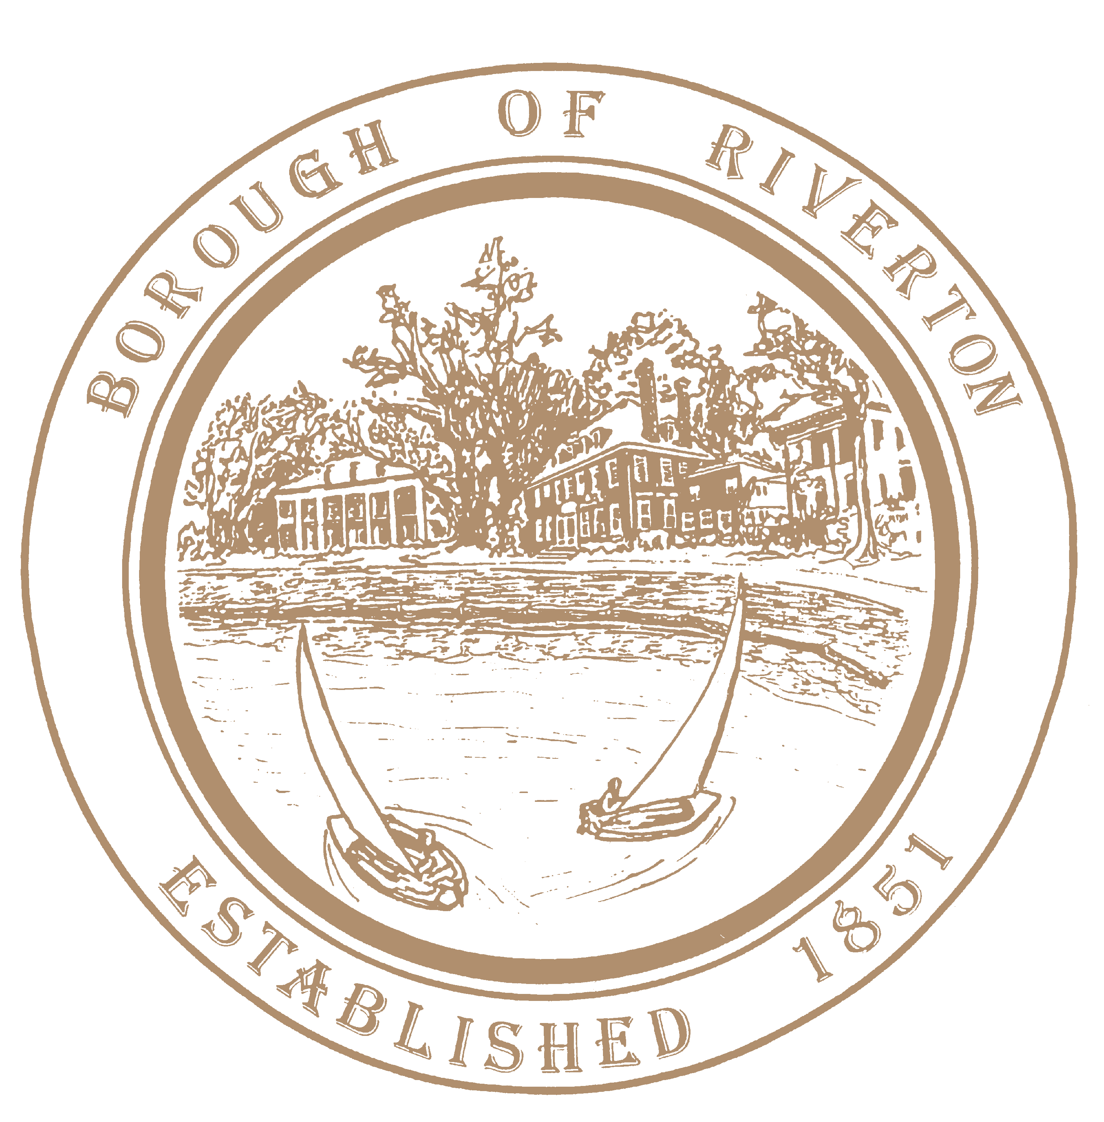

Mayor
Suzanne Cairns Wells

Borough Council
William Corbi, Council President Kirk Fullerton, Councilman
James Quinn, Councilman
Nicole Rafter, Councilwoman
Julie Scott, Councilwoman
Edgar Wilburn, Councilman
Michelle Hack, RMC, CMR Municipal Clerk mhack@riverton-nj.com

505A Howard Street
Riverton, NJ 08077
TELEPHONE: (856) 829-0120
Fax: (856) 829-1413
www.riverton-nj.com

P U B L I C N O T I C E
REQUEST FOR PROPOSALS AND QUALIFICATIONS
______________________________________________________________________________

NOTICE IS HEREBY GIVEN that sealed Request for Proposals and Request for Qualifications (RFP/RFQ) will be received by the Borough Clerk’s Office, for the Borough of Riverton, County of Burlington for:

2023 PROFESSIONAL SERVICES- LICENSED WASTEWATER TREATMENT C2 AND SEWER COLLECTION SYSTEM S2 OPERATOR SERVICES

FURTHER NOTICE is given that the deadline for RFP/RFQs to be received by the Borough Clerk’s Office, for the Borough of Riverton, County of Burlington, on Tuesday June 13, 2023, at 11:00 AM, at 505A Howard Street Riverton, New Jersey.

All proposals are being solicited through a “fair and open process” in accordance with N.J.S.A. 19:44A-20.5 et., and for the remainder of the 2023 calendar year.
Submission Instructions:

- Respondents are required to comply with the requirements of NJSA 10:5-31 et seq. and NJAC 17:27-1 et seq.

- Sealed RFP/RFQ packages shall include 1 printed copy of the proposal and 1 electronic file in the form of a USB of the respective proposal(s) should be submitted.

- The package should include detailed qualifications and fee schedules, insurance riders, New Jersey Business registration, W-9, sample contract, and Iran Russia Belarus Disclosure Form and New Jersey Public Works registration (if required).

- The Borough assumes no responsibility for delivery. Mailed submissions should be sent to the Borough Hall at the address given below and noted below:

Michelle Hack, Municipal Clerk
Borough of Riverton,
505A Howard Street,
Riverton, NJ 08077
“Proposal for 2023 Wastewater Treatment and Sewer Collections Operator for the Borough of Riverton”.

Selections will be based on the review of the documents and information submitted, as well as independent research performed by the Borough, such as a review of references, an evaluation of performance with other governmental and non-governmental entities and/or all other available information.

Attest:
Michelle Hack, RMC
Municipal Clerk

