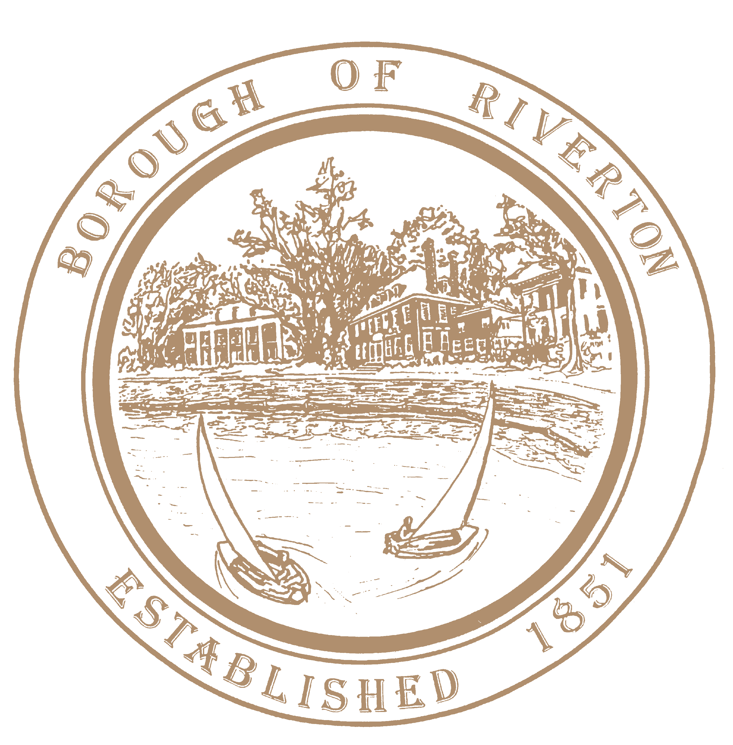

Mayor
Suzanne Cairns Wells

Borough Council
William Corbi, Council President Kirk Fullerton, Councilman
James Quinn, Councilman
Nicole Rafter, Councilwoman
Julie Scott, Councilwoman
Edgar Wilburn, Councilman
Michelle Hack, RMC, CMR Municipal Clerk mhack@riverton-nj.com

505A Howard Street
Riverton, NJ 08077
TELEPHONE: (856) 829-0120
Fax: (856) 829-1413
www.riverton-nj.com

Sunshine Notice
Change Location of a Scheduled Meeting of the
Governing Body of the Riverton Borough
___________________________________________________________________________________

PLEASE TAKE NOTICE in accordance with the Open Public Meeting Law, Chapter 231, P.L. 1975, this notice is hereby given that the June 20, 2023, 7 o’clock p.m. public meeting of the Governing Body of the Borough of Riverton, Burlington County location has changed from the Borough Hall to the Riverton School Gymnasium at 600 Fifth Street.

PLEASE TAKE NOTICE that formal action shall be taken.

PLEASE TAKE FURTHER NOTICE no Zoom or hybrid option will be offered for this meeting due to the location change. This meeting shall be live in-person only.

Attest:

Michelle Hack, RMC
Municipal Clerk

cc BCT
CP
Bulletin Board/Website
Governing Body

