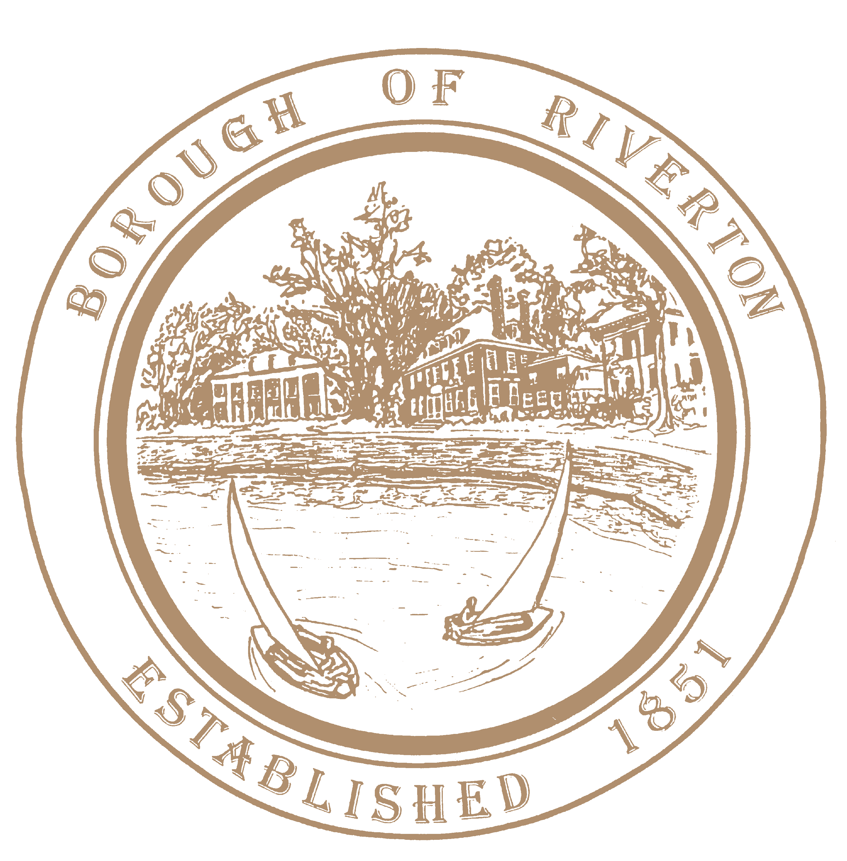
Mayor
Suzanne Cairns Wells

Borough Council
William Corbi, Council President Kirk Fullerton, Councilman Laura Major, Councilwoman Julie Scott, Councilwoman
James Quinn, Councilman Edgar Wilburn, Councilman
Michelle Hack, RMC, CMR Municipal Clerk mhack@riverton-nj.com

TELEPHONE: (856) 829-0120
Fax: (856) 829-1413
www.riverton-nj.com

BOROUGH HALL
505A Howard Street Riverton, NJ 08077

P U B L I C N O T I C E

Reorganization Meeting of the Governing Body of the Riverton Borough
___________________________________________________________________________________

PUBLIC NOTICE, is hereby given that the 2023 Reorganization meeting of the Governing Body of the Borough of Riverton is scheduled to take place at the Riverton School 600 Fifth Street, in the Gymnasium on Wednesday January 4, 2023 at 7 o’clock p.m.

PLEASE TAKE NOTICE that formal shall be taken.

Attest:

Michelle Hack, RMC
Municipal Clerk
December 14, 2022

CC: Mayor and Council
Borough Website and Official Bulletin Board
Burlington County Times
Courier Post

