The Short List: Our Top Natives – Shrubs, Herbaceous Perennials, Vines and Grasses

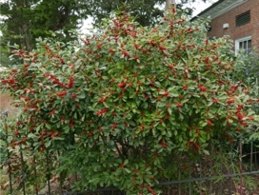
Common Winterberry (Ilex verticillata)
This perennial, deciduous shrub also goes by Michigan Holly, growing 6 to 10 feet tall normally, with purplish green foliage that turns black at the first frost. Small flowers bloom during the spring and early summer, followed by clusters of bright red berries that persist throughout the winter. This tree tolerates a variety of conditions, growing in full sun to shade, in dry to wet, sandy to clayey soils. Plant one male for every 5 female plants. Attracts robins, mockingbirds, catbirds, thrushes.

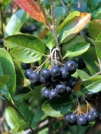
Black Chokeberry (Aronia melanocarpa)
This deciduous, spreading shrub typically grows 3 to 6 feet in height and width. It grows clusters of showy white flowers that give way to black, bitter berries often used to make jams and jellies. This plant can grow in full sun to partial shade, and in moist, well-drained soils, though it grows fruits best in full sun. Foliage deepens to deep purples and burgundies in autumn.

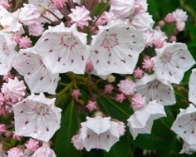
Mountain Laurel (Kalmia latifolia)
This east coast native is the state flower for Pennsylvania and Connecticut. An evergreen shrub reaching 5-15 feet tall that thrives in rich, well-drained, acidic soils, this plant often grows in large colonies covering forest floors. Its flowers combine to form a large ball, that range from light pink to a darker rosy color, covering the plant for several weeks in May-June. Plants tolerate full sun to full shade but do best in part shade. Prune lightly after flowering.

Virginia Sweetspire (Itea)
Virginia Sweetspire is a native deciduous to semi-evergreen shrub that can grow up to 8 feet tall though there are shorter cultivars on the market. In early summer, small, fragrant, white flowers Itea prefers moist, rich, slightly acidic huusy soils in partial sun to partial shade, but tolerates a wide range of soil conditions and pHs. Best flowering occurs with 4 hours of sun per day. It can form dense colonies by root suckering and can be used for erosion control in wet areas or on wet banks. This plant blooms on previous season's wood, so pruning should be done after flowering. Use in a mass for spectacular spring flowers.
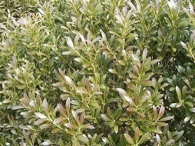
Inkberry Holly (Ilex Glabra)
A smooth leaf evergreen holly native to the east coast, Inkberry can grow 5–8 feet without pruning. There are now cultivars available that resemble small boxwood and top out at around 3 feet tall. A lovely choice for informal hedging or for low formal repetition in a garden.

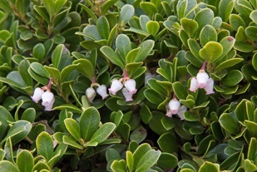
Red Bearberry (Arctostaphylos uva-ursi)
Also known as Kinnikinnick and Pinemat Manzanita, it is a mat-forming, evergreen shrub that grows 6 to 12 inches tall and up to 6 feet wide. In the spring, it produces lovely white and pink, bell-shaped flowers that later turn into red berries. True to its name, the fruits of this plant are enjoyed by bears, as well as birds and other wildlife. It can grow in full sun to shade, and in dry to moist rocky or sandy, acid soils.

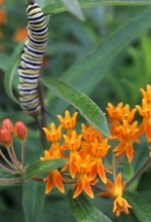
Butterfly Milkweed (Asclepias tuberosa)
Other common names for this nectar-rich perennial include Orange Milkweed and Pleurisy Root. It typically grows in clumps up to 1 to 3 feet tall, and features clusters of bright orange to yellow-orange flowers. Its blooms are attractive to both butterflies and hummingbirds, and like all milkweeds, it serves as a host plant for butterfly species including the Monarch. Drought tolerant, this plant grows in full sun.

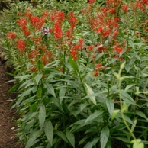
Cardinal-Flower (Lobelia cardinalis)
Cardinal-Flower is a short-lived perennial that grows up to 6 feet tall and is capable of thriving in standing water or average soil. From mid-summer to fall it produces showy red flowers at the end of terminal spikes that are especially attractive to hummingbirds. This plant can grow in full sun to shade, but its soil must always be kept moist or wet.

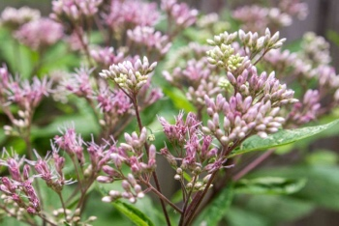
Coastal-Plain Trumpetweed (Eutrochium dubium)
Also called Joe Pye, this herbaceous perennial typically grows 3 to 5 feet tall and 2 to 4 feet wide. It produces coarse foliage and clusters of small, disk flowers ranging in color from pale pink to dark purple from July to September. This plant grows in full sun to partial shade and in moist to wet soil. It can tolerate deer browsing, and its showy, fragrant flowers attract butterflies.
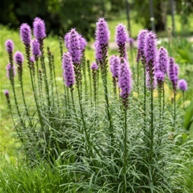
Dense Gayfeather (Liatris spicata)
Also known as Blazing Star, this herbaceous perennial grows 3 to 4 feet tall. It has grass-like leaves that are clumped toward the base of the plant and continue up the stem till they reach the showy flower cluster: a tall spike of rayless, densely packed, rose-purple or white flower heads. This plant grows in full sun and moist soils and is favored by butterflies as well as hummingbirds.

Farewell-Summer (Symphyotrichum lateriflorum)
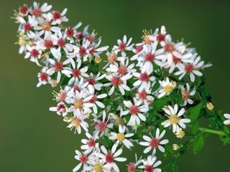
Also known as Calico Aster and Side-flowering Aster, this perennial herb grows about 1 to 3 feet tall, branching occasionally. Its stems are light green or reddish brown with lines of white hairs. It produces numerous, small, pale-colored flowers with centers that change from yellow to reddish purple at maturity. This plant does well in full sun to partial shade and moist soils, tolerating occasional flooding.

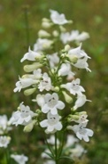
Foxglove Beardtongue (Penstemon digitalis)
Also called Mississippi Penstemon or Smooth White Penstemon, this is a clump-forming plant that typically grows 3 to 5 feet tall. It produces white, two-lipped, tubular flowers atop erect, rigid stems from mid-spring to early summer. Attracting hummingbirds and bumblebees, this plant grows in full sun to partial shade and in dry to wet, fertile, and well-drained soils.

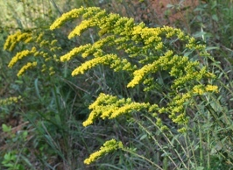
Gray Goldenrod (Solidago nemoralis)
This perennial, deciduous plant is also called Prairie, Oldfield, Grayleaf, Dwarf, or Field Goldenrod. One of the smallest species of goldenrod, it grows to about 2 feet in height, producing bright yellow flower heads from August to November. This herb is moderately deer-resistant and grows in full sun to shade, in dry sandy, rocky, and clay soils.

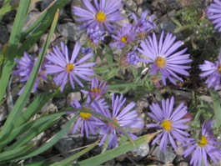
Late Purple American-Aster (Symphyotrichum patens)
This is an upright, perennial herb that typically grows to 2 1/2 feet tall on slender, hairy stems. It produces daisy-like flowers with blue to violet rays and yellow centers from August to October. This plant is drought tolerant, growing in full sun and partial shade, and in moist to dry soils.

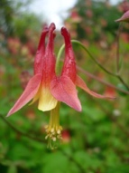
Red Columbine (Aquilegia canadensis)
Also known as Eastern Red Columbine and Wild Columbine, this herbaceous perennial grows erectly with uniquely bell-shaped, red flowers. The backward-pointing tubes of the flowers contain nectar, greatly attracting hummingbirds, butterflies, and other long-tongued insects. This plant grows best in full sun, and moist, well-drained, sandy soils, reaching a height of up to 2 feet.

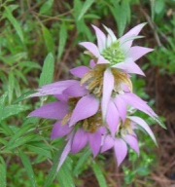
Spotted Beebalm (Monarda punctata)
Also called Spotted Horsemint or simply Horsemint, this aromatic perennial grows up to 3 feet tall and attracts pollinators such as bees and butterflies. A central stem produces two or more dense whorls of yellowish, purple-spotted flowers with purplish bracts in the upper portion of each plant. It is drought tolerant, growing in full sun, and in dry, sandy soils.

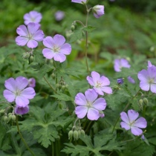
Spotted Crane's-Bill (Geranium maculatum)
Also known as Wild or Spotted Geranium, this herbaceous perennial grows up to 1 1/2 feet tall. Named for the shape of its seed capsule, this clump-forming wildflower spreads easily and does best in partial shade and moist soils. Its showy, pink or lavender flowers attract pollinators like bees, as well as birds that feed on this plant’s seeds.

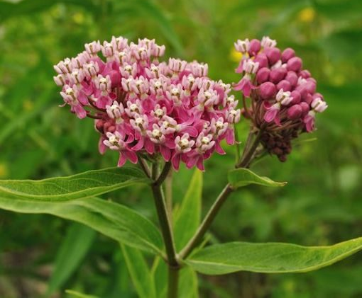
Swamp Milkweed (Asclepias incarnata)
Swamp Milkweed, or Pink Milkweed, is an herbaceous perennial that typically grows 3 to 4 feet tall on branching stems. It bears clusters of small, fragrant, pink to mauve flowers that are highly attractive to butterflies and hummingbirds. This plant is a valuable food source for Monarch caterpillars. Swamp Milkweed is a great plant for low spots or other moist areas in the landscape, as it grows in full sun to partial shade, and in rich and even muddy soil.

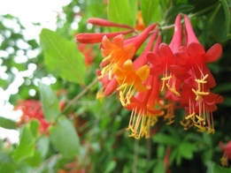
Coral honeysuckle (Lonicera sempervirens)
Also known as trumpet honeysuckle this native species is known for coral red flowers that attract hummingbirds and long-tongues pollinators. Slow-growing compared to the Asian species, trumpet honeysuckle can grow to 20 feet over time. It does not spread underground and keeps a tidy habit.

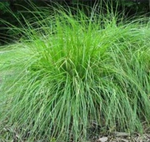
Appalachian Sedge (Carex appalachica)
Appalachian sedge is a fine-textured green clump-forming sedge that performs well in dry, shady woodlands. The habit is arching, like a green fountain, which makes this sedge attractive in containers. Grows well on slopes and is a host for several caterpillars. Native sedges make wonderful lawn alternatives. Deer resistant.
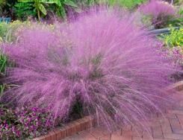
Pink Muhly Grass (Muhlenbergia capillaris)
This hardy native grass provides stunning late season color when its soft pink seed heads float above its fronds. This grass is deer resistant, thirves in nearly any soil type and tolerates heat, humidity and even droughty conditions.

